Adagrad full form adaptive gradient.
In adagrad we don’t have a fixed learning rate, e change it and adapt it to the current scenario.
Adagrad or adaptive gradient works better when we have features that have different scales like age or salary.
When we have Sparsity in features we can use adagrad
Sparsity in features creates a problem called Elongated ball problem, in this problem the contour plot circles are elongated to one side. In such case, slope along one axis changes but for second axis it remains normal. Due to sparsity, gradient calculated will be very small, due to which a little change in the weights will take place and more steps it will take to converge to the solution

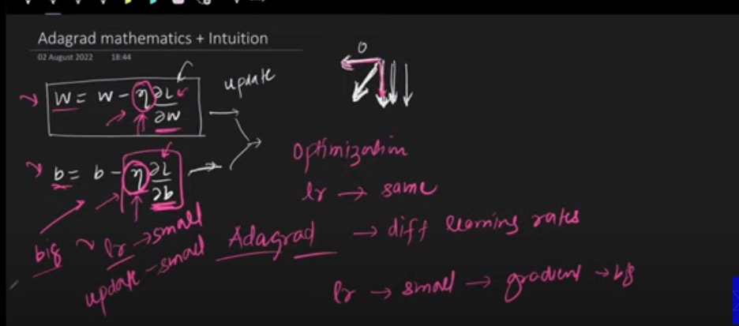

Agar gradient zero hai to update bhi zero ho jaye ga, or aik hi direction mn move karay ga, likin ham chahty hain ky daramayan walay arrow ki trhan move karay na ky kisi aik direction mn.
AdaGrad ye krta hai agar kisi parameter (weight, bias) ka update or gradient bht bara hai to usy choty leanring rate sy multiply kr dy or agar kisi parameter ka update or gradient bht chota hai to usy baray learning rate sy multiply kr dy. Adagrad bs yehi krta hai.

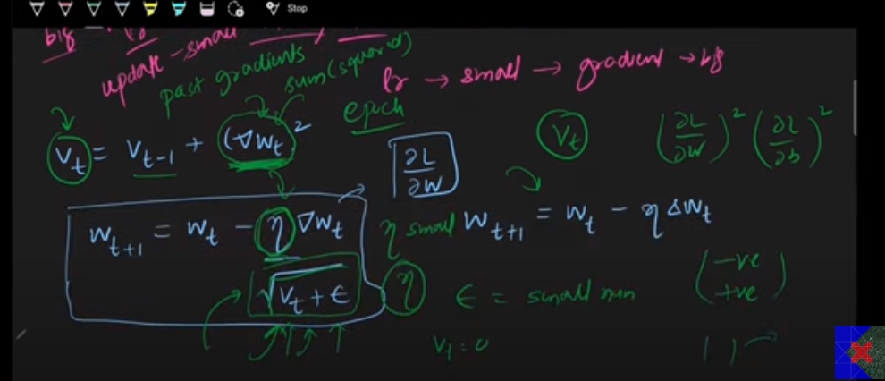
Jo Vt hai wo past walay gradients ky square ka sum hai, if we are at 100 epoch the Vt will contain past 99 weights sum of quares which makes the learning rate extremely small and adagrad fails to reach the global minima it reaches near minima
Oper wala update formula mn ham aik term underroot(Vt + epsiolon) sy divide krty hain, agar to gradient chota hai to learning rate bara ho jaye ga or agar gradient bht bara hai to division ky bd learning rate chota ho jaye ga.

Advantage:
Adagrad is used when we have sparsity (a lot of 0 values in data) or unscaled features or features having different scales.

Disadvantage:
Used in linear regression
Not used for complex neural network because adagrad never reaches to solution it reaches near the solution. Because we divide the learning rate with the previous gradient which makes learning rate very small because Vt (past gradient with time increases).

